Autonomous AI Healthcare Operations Coordinator - Langgraph - 2.5 Flash

Project Description:
CareSync AI is a dataset-driven, multi-agent hospital operations platform that coordinates emergency patient surges across every operational department of a hospital. The application enforces a strict Zero Preloaded Data Policy — it starts completely empty, with no hardcoded numbers, fake patients, or sample metrics, and becomes fully live only after a user uploads a real hospital operational dataset (CSV, Excel XLSX/XLS, or JSON).
At its core, CareSync AI runs a Hospital Coordinator Agent alongside six specialized agents — Bed Management, Appointment, Lab, Pharmacy, Staffing, and Discharge — that analyze the live hospital database in sequence to assess capacity, reroute diagnostics, flag medicine shortages, reallocate staff, reschedule routine appointments, and release discharge-ready beds during an emergency surge.Built with Flask and SQLAlchemy on a SQLite database, CareSync AI streams live agent status updates to the browser using Server-Sent Events, renders operational KPIs and charts with Plotly, and dispatches real patient SMS and WhatsApp notifications through Twilio whenever a routine appointment is rescheduled during a surge — automatically switching to a safe "Twilio Mock Mode" when Twilio credentials are not present. Together, these pieces let hospital administrators simulate and study emergency response using their own operational data, in a fully auditable, database-backed workflow.

Scenarios
Scenario 1: A hospital administrator uploads their operational dataset and creates a scenario describing "40 incoming emergency patients following a highway accident." The Coordinator Agent reads live bed, staffing, lab, pharmacy, appointment, and discharge data from the database, determines there is a capacity gap, and dispatches the six specialized agents in sequence to resolve it — rescheduling routine appointments, flagging critical medicine shortages, and releasing discharge-ready beds.
Scenario 2: During the Appointment Agent's run, several patients with routine, non-urgent appointments scheduled for the surge window are automatically identified for rescheduling. CareSync AI sends each affected patient a real SMS (or WhatsApp message, if opted in) via Twilio confirming their new appointment slot, while dataset-only records are silently marked "Not Required" to avoid notification spam.
Scenario 3: A user uploads a dataset with inconsistently named columns (e.g., "Pt_Name", "Bed_Stat"). The Dataset Ingestion Engine calls the Gemini Dataset Mapper, which semantically maps each source column to CareSync AI's internal schema (name, status, ward, etc.). If the Gemini API key is unavailable, the platform automatically falls back to deterministic fuzzy-matching rules so the dataset still ingests correctly.

Technical Architecture:
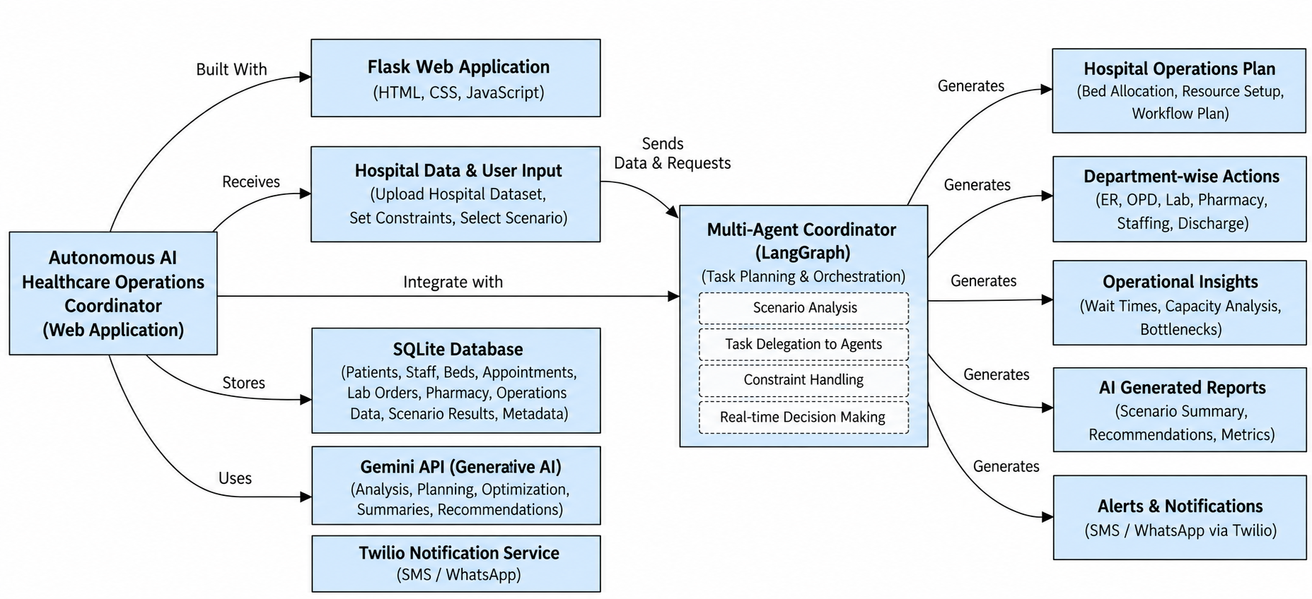

Description:CareSync AI follows a modular, database-centered architecture. The frontend is built with server-rendered Jinja2 templates (HTML/CSS/vanilla JavaScript), styled with a light indigo/violet SaaS theme and dynamic Plotly charts, and it listens to a Server-Sent Events (SSE) stream for live agent status updates. The Flask backend exposes page routes and JSON APIs for authentication, dataset upload, scenario management, and each operational module (Patients, Appointments, Beds, Labs, Pharmacy, Staffing, Discharge, Reports). All operational state is persisted in a SQLite database through SQLAlchemy models. Uploaded datasets are parsed with pandas, semantically mapped to the internal schema via the Gemini Dataset Mapper (services/dataset_mapper.py + services/gemini_service.py), and ingested into normalized tables by the Dataset Manager (services/dataset_manager.py). The Scenario Manager (services/scenario_manager.py) orchestrates the Coordinator Agent and the six specialized agents (agents/*.py) in a fixed pipeline against this live data, publishing progress events through the Event Manager (services/event_manager.py) and dispatching patient notifications through the Twilio Service (services/twilio_service.py) and Appointment Workflow Service (services/appointment_workflow.py).

Entity-Relationship Diagram:

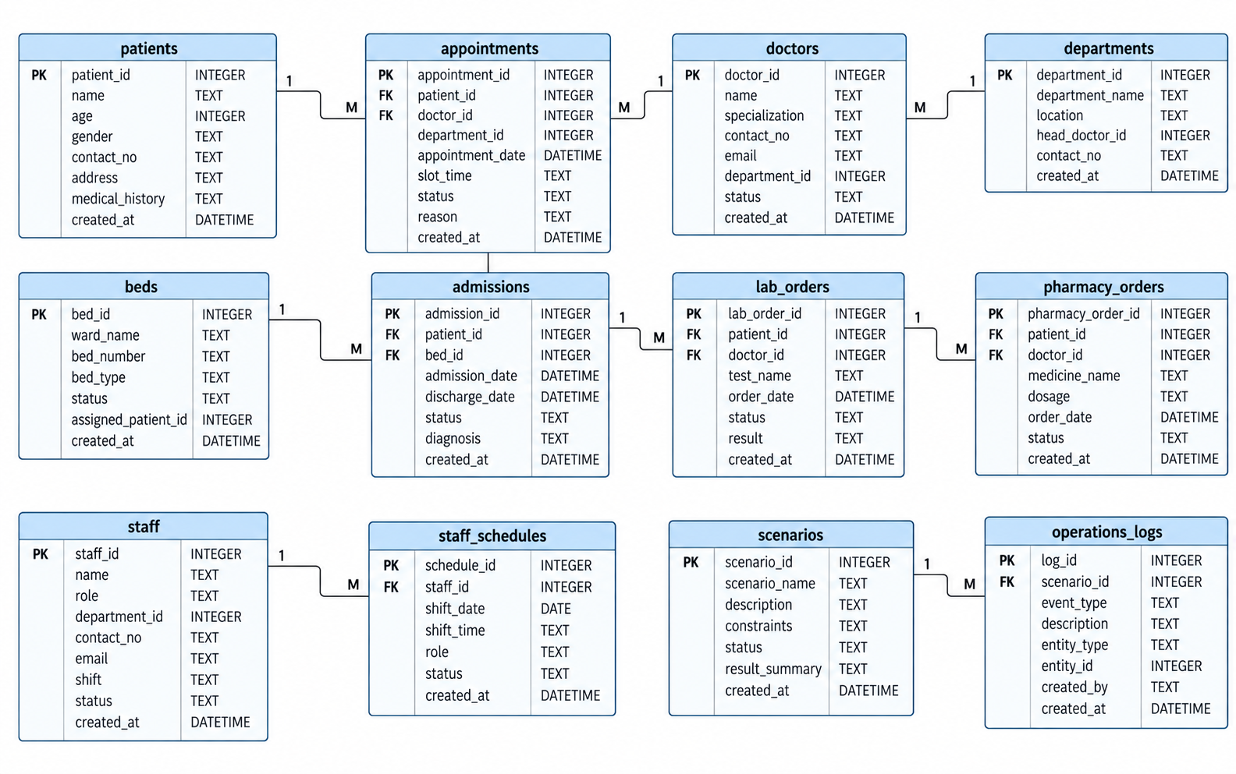

Description:The ER diagram represents the database structure of the Autonomous AI Healthcare Operations Coordinator. It manages important hospital entities such as patients, doctors, departments, appointments, beds, admissions, laboratory orders, pharmacy orders, staff, staff schedules, scenarios, and operational logs. The relationships between these entities allow the system to maintain and access hospital information efficiently. This structured database supports the LangGraph multi-agent system by providing the required operational data for resource analysis, appointment management, staff coordination, laboratory and pharmacy operations, scenario handling, and generation of AI-driven healthcare recommendations.

Pre-requisites:
- Flask Framework Knowledge: Flask Documentation
- SQLAlchemy ORM Familiarity: SQLAlchemy Documentation
- Google Gemini API Familiarity: Gemini API Documentation
- Twilio API Familiarity: Twilio Docs (SMS & WhatsApp)
- pandas / openpyxl Familiarity: pandas Documentation
- HTML, CSS, and JavaScript Skills: W3Schools HTML/CSS/JavaScript Tutorials
- Python Programming Proficiency: Python Documentation
- Version Control with Git: Git Documentation
- Development Environment Setup: Flask Installation Guide

Project Workflow:

Milestone 1: Model Selection and Architecture
- Activity 1.1: Generate a Gemini API key and configure it securely in the project environment.
- Activity 1.2: Generate Twilio credentials for SMS and WhatsApp patient notifications.
- Activity 1.3: Research and select the appropriate generative AI model for dataset mapping and operational summarization.
- Activity 1.4: Define the architecture of the application — frontend, Flask backend, database, agent engine, and third-party integrations.
- Activity 1.5: Set up the development environment, installing all required libraries and dependencies.

Milestone 2: Core Functionalities Development
- Activity 2.1: Implement the Zero Preloaded Data Policy and the dataset ingestion engine (CSV/XLSX/JSON parsing + Gemini/rule-based column mapping).
- Activity 2.2: Develop the Multi-Agent Engine — the Coordinator Agent and the six specialized operational agents.
- Activity 2.3: Implement the Twilio SMS/WhatsApp notification workflow for rescheduled appointments, with automatic Mock Mode.
- Activity 2.4: Implement real-time agent status streaming to the frontend using Server-Sent Events.

Milestone 3: App.py Development
- Activity 3.1: Write the main application logic in app.py — authentication, page routes, and every REST API endpoint that powers the platform.

Milestone 4: Frontend Development
- Activity 4.1: Design and develop the user interface using HTML, CSS, and JavaScript across every operational module page.
- Activity 4.2: Create dynamic dashboards, live agent-status widgets, and Plotly charts driven by SSE events and REST responses.

Milestone 5: Deployment
- Activity 5.1: Prepare the application for local deployment — virtual environment, dependency installation, sample dataset generation.
- Activity 5.2: Verify the full end-to-end flow: sign up, confirm empty state, upload dataset, run an emergency surge scenario.
- Activity 5.3: Deploy the application publicly using Ngrok, exposing the local Flask server through a secure public URL and validating end-to-end accessibility and functionality.

Milestone 6: Conclusion

Milestone 1: Model Selection and Architecture
In this milestone, we focus on provisioning the two external AI/communication services CareSync AI depends on — Google Gemini for intelligent dataset mapping and narrative summaries, and Twilio for real patient SMS/WhatsApp alerts — and on defining the overall application architecture before writing any feature code.

Activity 1.1: Generate a Gemini API Key
Before the application can call the Gemini model, you need a valid API key from Google AI Studio, stored securely and never committed to source control.
• Step 1 — Create a Google AI Studio Account: Visit https://aistudio.google.com and sign in using your Google account.
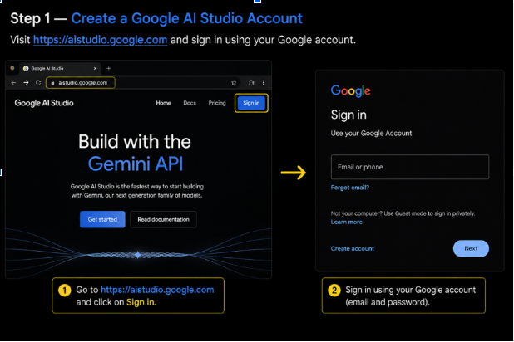
• Step 2 — Navigate to API Keys: Once signed in, open the "Get API key" section from the left navigation, or go directly to https://aistudio.google.com/apikey.
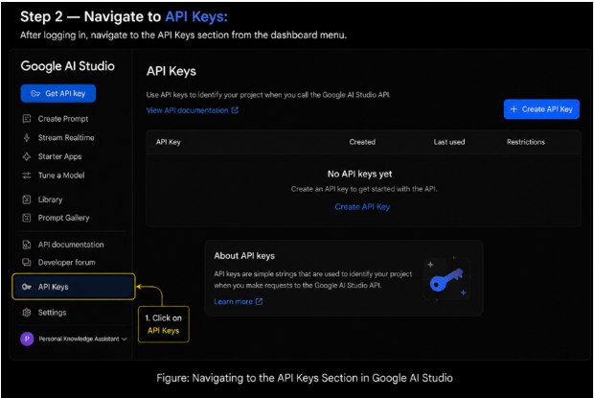
• Step 3 — Create a New API Key: Click "Create API key", choose or create a Google Cloud project to associate it with, and confirm.
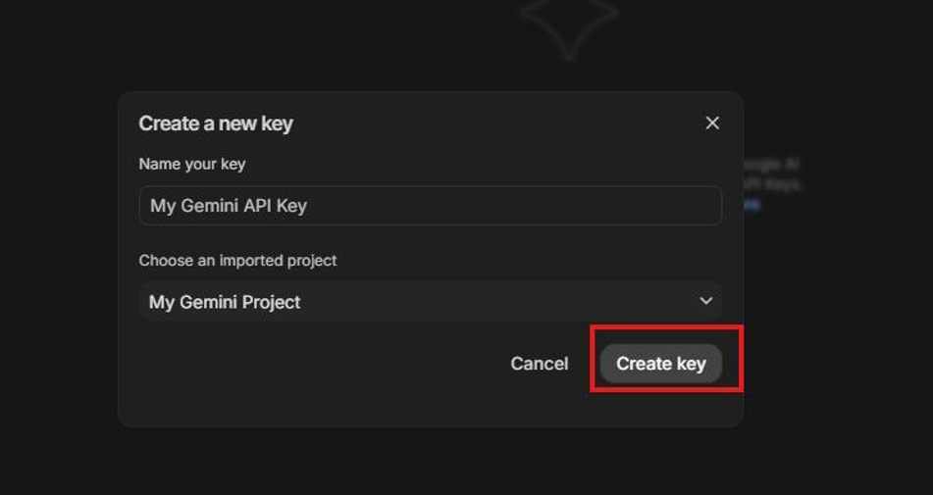
• Step 4 — Copy the API Key: Copy the generated key immediately and store it in a safe place — treat it the same way you would a password.
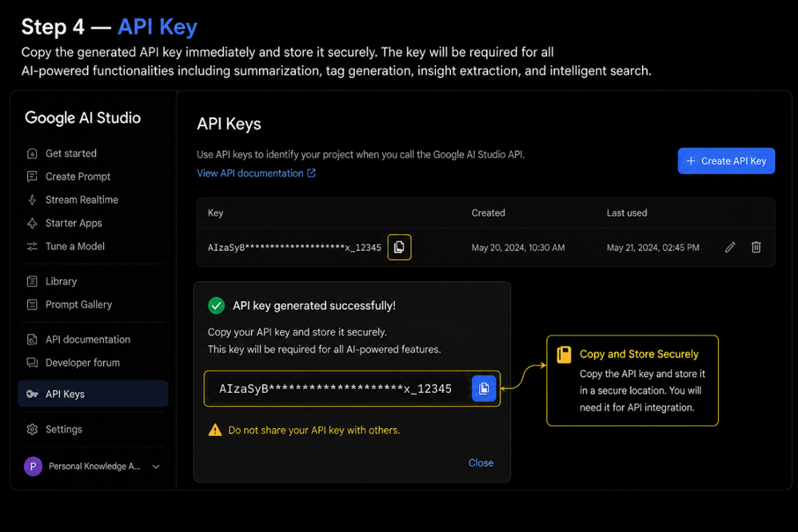
• Step 5 — Add the Key to Your Project: Copy .env.example to .env in the project root and paste the key as shown below:
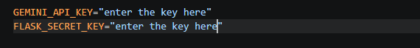
• Step 6 — Verify the Key is Loaded: The ai/gemini_insights.py module loads this key automatically using python-dotenv:
• Important — Never Commit Your API Key: .env is already listed in .gitignore to prevent accidentally pushing the key to a public repository.

Activity 1.2: Configure Twilio for SMS & WhatsApp Notifications
CareSync AI notifies real patients by SMS (and optionally WhatsApp) whenever the Appointment Agent reschedules a routine appointment during a surge.
- Step 1 — Create a Twilio Account: Sign up at https://www.twilio.com and open the Twilio Console.
- Step 2 — Get Account Credentials: From the Console dashboard, copy the Account SID and Auth Token.
- Step 3 — Get a Twilio Phone Number: Provision a Twilio phone number (or use the WhatsApp Sandbox number for testing WhatsApp messages).
- Step 4 — Add Credentials to .env:
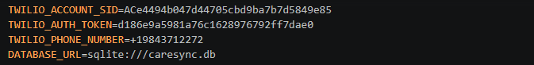
- Step 5 — Verify Graceful Mock Mode: services/twilio_service.py only initializes a live Client when all three credentials are present; otherwise get_status() reports “Twilio: MOCK MODE” and notifications are simulated instead of sent, so the app remains fully usable without a Twilio account:

Activity 1.3: Research and Select the Appropriate Generative AI Model
- Understand the Project Requirements: CareSync AI needs fast, low-latency AI calls for two tasks — mapping arbitrary spreadsheet column names to a fixed internal schema, and turning raw operational metrics into a short, factual narrative summary.
- Explore Gemini's Model Documentation: Review Gemini's available models for response speed, JSON-following reliability, and cost.
- Evaluate Model Performance: A strict 2.5-second timeout is enforced on every Gemini call (via a ThreadPoolExecutor future) so a slow AI response never blocks the request/response cycle of the Flask app.
- Select the Optimal Model: Choose gemini-2.5-flash for its balance of response speed and reasoning quality, used consistently across both the primary google-genai client and the legacy google-generativeai fallback.

Activity 1.4: Define the Architecture of the Application
- Draft the Component Diagram: Frontend (Jinja2 templates + static CSS/JS + Plotly + SSE listener) → Flask app.py (routes & APIs) → Service layer (dataset_manager, scenario_manager, gemini_service, twilio_service, event_manager, appointment_workflow) → SQLAlchemy models → SQLite database.
- Detail Frontend Functionality: Users sign up/sign in, land on an empty dashboard, upload a hospital dataset, create an emergency scenario with a free-text instruction, and watch the Coordinator + six agents execute live.
- Outline Backend Responsibilities: The Flask backend authenticates users, ingests and normalizes uploaded datasets, orchestrates the multi-agent pipeline against the live database, streams progress over SSE, and dispatches Twilio notifications.
- Describe AI Integration Points: Gemini is called from services/dataset_mapper.py (column mapping) and from every agent's execute() method via gemini_service.generate_scenario_summary() / generate_final_operational_summary() for the human-readable narrative.

Activity 1.5: Set Up the Development Environment
- Install Python and Pip: Ensure Python 3.10+ is installed along with pip.
- Create a Virtual Environment:
- Install Project Dependencies: requirements.txt lists every dependency used by the project:
- Configure the API Keys: Create the .env file in the project root with GEMINI_API_KEY, TWILIO_ACCOUNT_SID, TWILIO_AUTH_TOKEN, TWILIO_PHONE_NUMBER, DATABASE_URL, and SECRET_KEY.
- Set Up the Application Structure: app.py, agents/ (7 agent modules), services/ (8 service modules), templates/ (19 Jinja2 pages), static/css, static/js, and instance/caresync.db (created automatically by SQLAlchemy on first run).

Milestone 2: Core Functionalities Development
Milestone 2 covers the three functional pillars of CareSync AI: the dataset ingestion engine that brings a hospital's real operational data into the platform, the seven-agent orchestration engine that reasons over that data during an emergency scenario, and the notification/real-time layers (Twilio and SSE) that make the agents' work visible and actionable.

Activity 2.1: Zero Preloaded Data Policy & Dataset Ingestion Engine
Until a user uploads a dataset, every dashboard, KPI, chart, and agent status shows an empty/waiting state — there is no seed or mock data anywhere in the database.
- Multi-format Parsing: services/dataset_manager.py accepts CSV, XLSX/XLS (including multi-sheet workbooks), and JSON uploads, using pandas to read each file into one DataFrame per detected category.
- Category Detection: dataset_mapper.detect_category() inspects the sheet/file name and column headers to classify each table as PATIENTS, APPOINTMENTS, BEDS, LABS, PHARMACY, STAFF, or DISCHARGE.
- AI-Assisted Column Mapping: For each detected category, gemini_service.map_dataset_columns() asks Gemini to semantically map arbitrary source column names (e.g. “Pt_Name”) onto the platform's fixed internal schema, using sample row data as context:
- Deterministic Fallback: If Gemini is unavailable or the call times out, dataset_mapper.py falls back to rule-based fuzzy matching so ingestion never fails outright.
- Normalized Ingestion: Once mapped, each category is ingested into its corresponding SQLAlchemy table (Patient, Appointment, Bed, LabTest, PharmacyItem, StaffMember, DischargeRecord) tagged with source='dataset', and any pre-existing operational records for that user are cleared first so the platform always reflects the latest upload.

Activity 2.2: Develop the Multi-Agent Hospital Operations Engine
Seven agents live under agents/, each implementing an analyze/execute pattern that reads live SQLAlchemy-backed data for the current user and returns a structured result (key findings, operational record tables, chart data, and an AI narrative):
- Coordinator Agent (agents/coordinator.py): Parses the incoming-patient count from the user's free-text scenario instruction, queries bed/lab/pharmacy/staffing/appointment/discharge tables, computes a capacity gap, and issues a surge verdict (CAPACITY AVAILABLE / UNDER PRESSURE / INSUFFICIENT) plus a per-domain instruction for each of the six specialized agents.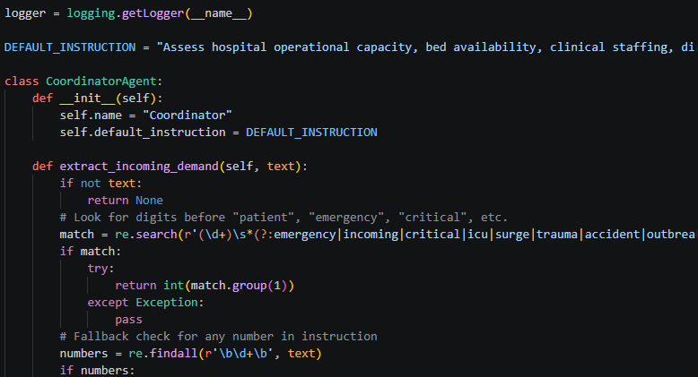
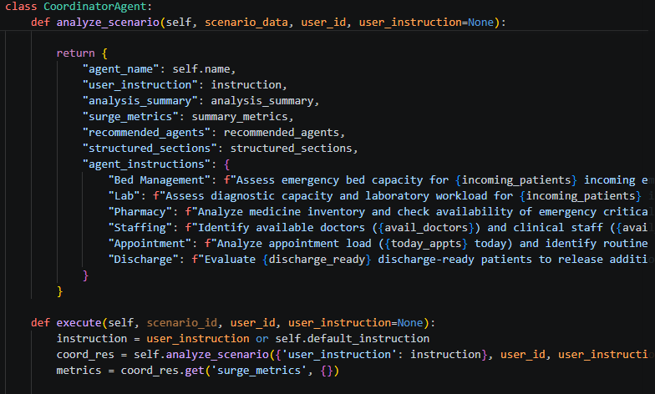
- Bed Management Agent (agents/bed_agent.py): Assesses bed capacity and ICU/ward availability against the incoming demand.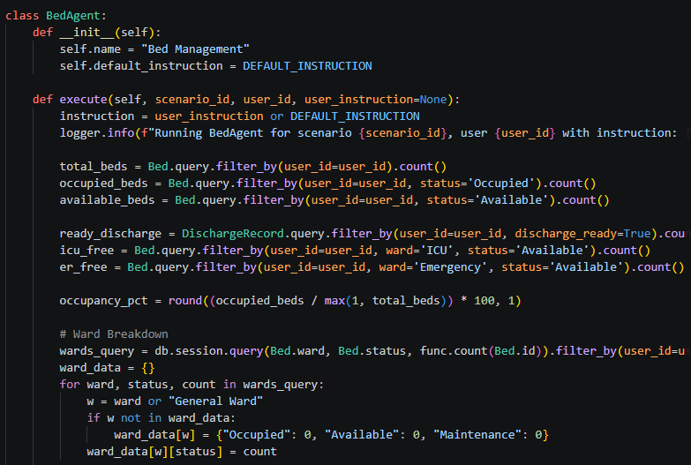
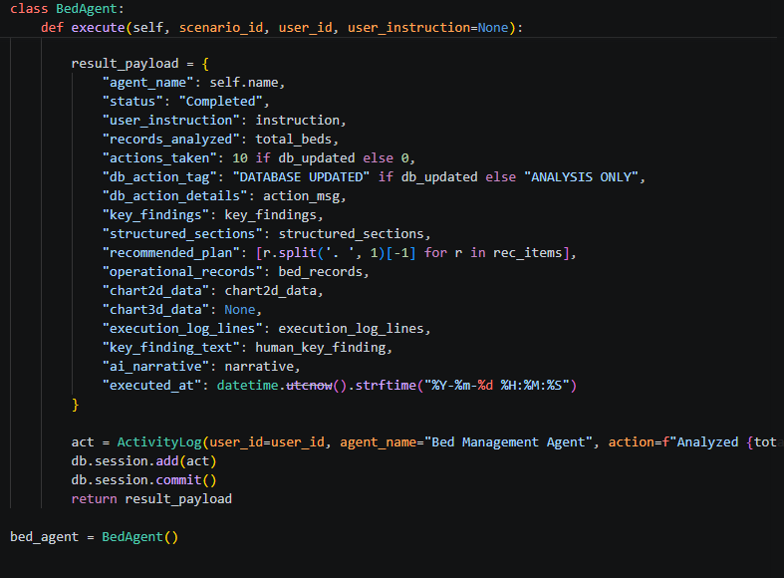
- Appointment Agent (agents/appointment_agent.py): Identifies routine appointments during the surge window and reschedules them, triggering patient SMS/WhatsApp notifications.
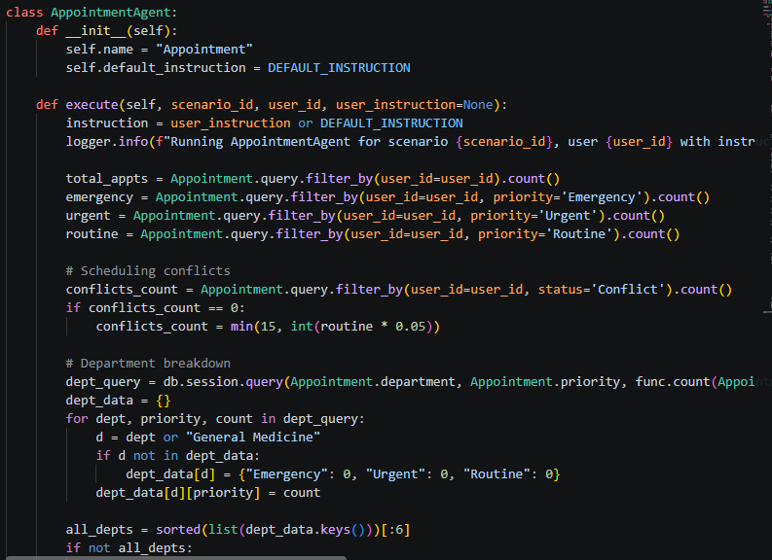
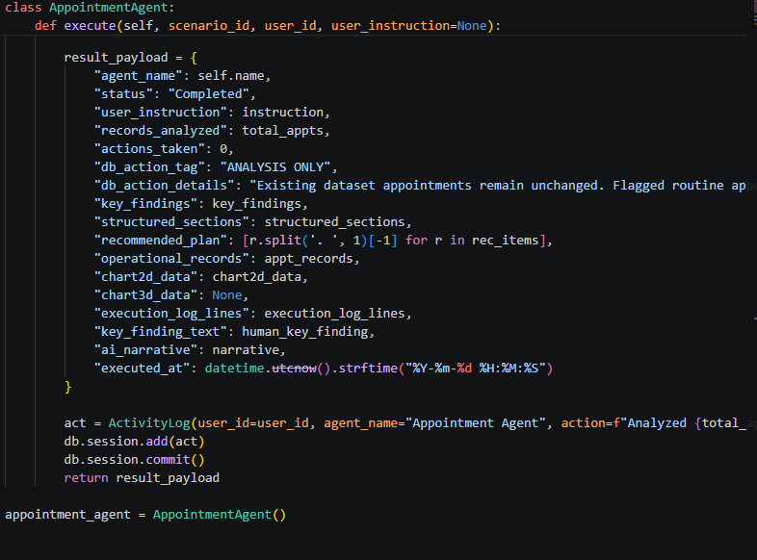
- Lab Agent (agents/lab_agent.py): Identifies pending and emergency-priority diagnostic bottlenecks and recommends rerouting.
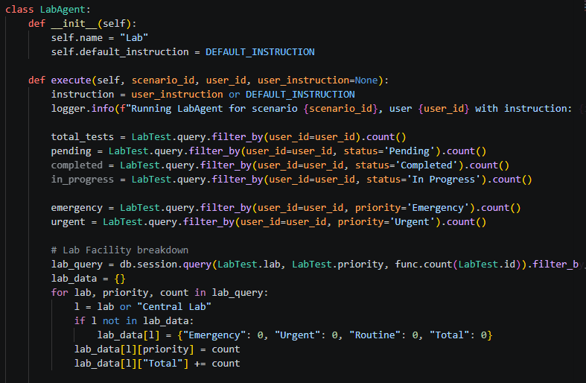
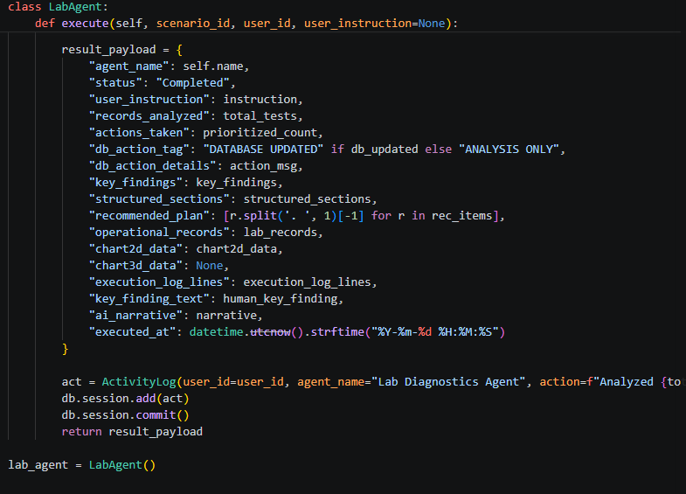
- Pharmacy Agent (agents/pharmacy_agent.py): Scans medicine stock against required quantity and flags critical/low shortages.
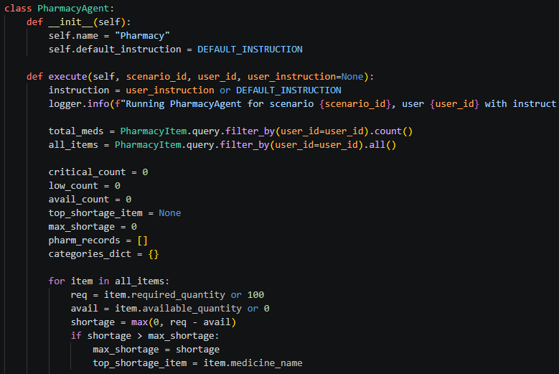
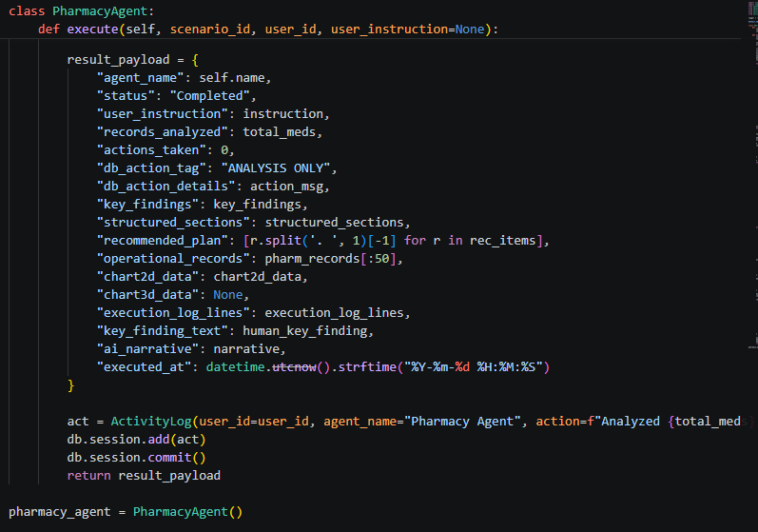
- Staffing Agent (agents/staffing_agent.py): Reallocates available doctors and nurses to emergency triage.
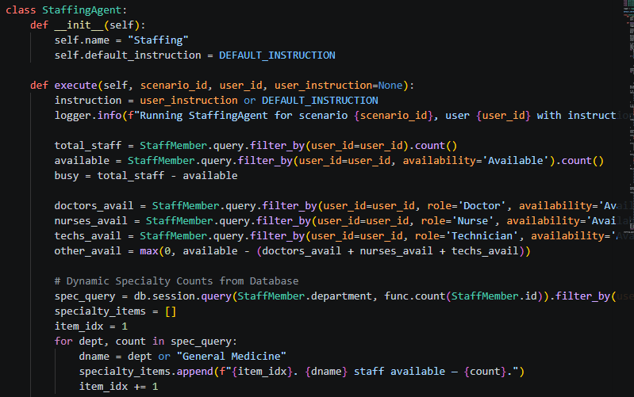
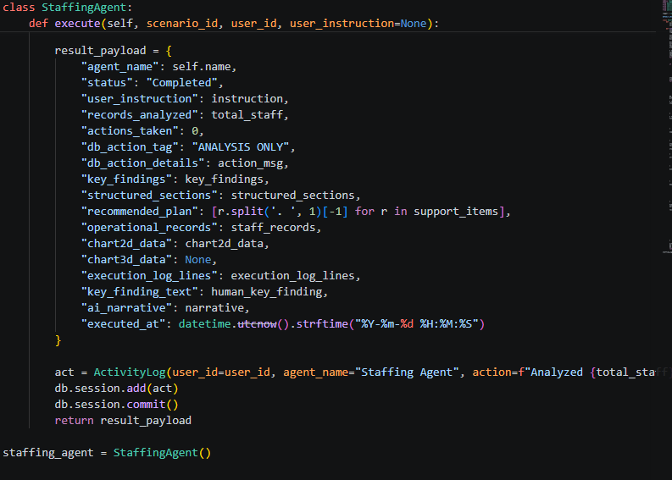
- Discharge Agent (agents/discharge_agent.py): Evaluates discharge-ready patients to release additional bed capacity back into the pool.
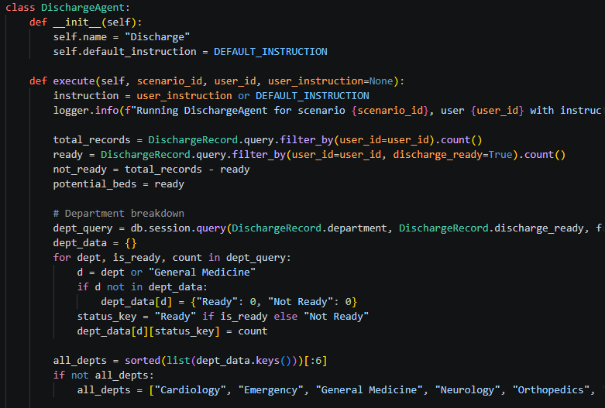
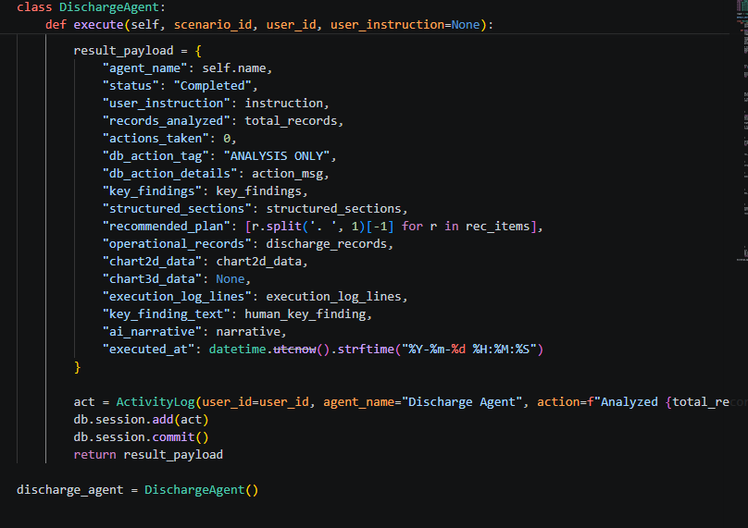
The Scenario Manager (services/scenario_manager.py) is the orchestrator: it runs the Coordinator Agent first to build a recommended agent list and per-agent instructions, then executes each of the six specialized agents in a fixed sequence against the same live database, persisting a ScenarioAgentRun record and publishing a live event for every state transition (Waiting → Running → Completed).

Activity 2.3: Implement the Twilio SMS/WhatsApp Notification Workflow
- Appointment Rescheduling Trigger: services/appointment_workflow.py analyzes patient condition/symptoms to recommend a department, finds available doctors and time slots, creates the appointment record, and triggers a notification.
- SMS/WhatsApp Dispatch: services/twilio_service.py sends the confirmation via Twilio's REST API when a live client is configured.
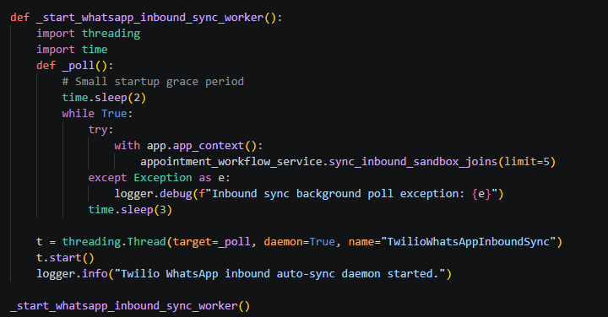
- Mock Mode Safety Net: When Twilio credentials are absent, the same code path records a simulated “✓ SMS Simulated” notification instead of raising an error, so demos and development never depend on a paid Twilio number.
- Dataset-only Records Skip Notification: Appointments ingested directly from an uploaded dataset are marked notification status “Not Required” to avoid spamming patients whose data was bulk-imported rather than actively scheduled.

Activity 2.4: Real-Time Agent Event Streaming
- Server-Sent Events: services/event_manager.py maintains a list of Python queue.Queue subscribers. Every scenario/agent state change is pushed to all active subscribers as a JSON payload.
- SSE Endpoint: GET /api/agent-events in app.py streams these events to the browser using Flask's Response with mimetype text/event-stream, allowing the dashboard and scenario workspace pages to update agent status live without polling.

Milestone 3: App.py Development
Milestone 3 focuses on app.py, the 1000+ line Flask application that wires together authentication, every page route, and every REST API endpoint used by the frontend, agents, and dataset engine.

Activity 3.1: Writing the Main Application Logic in app.py
- Application & Database Initialization: app.py loads environment variables, configures the Flask SECRET_KEY and SQLALCHEMY_DATABASE_URI, and calls init_db(app) to create all SQLAlchemy tables on first run.
- Login-Required Decorator: A custom login_required decorator guards every authenticated page/API route, redirecting to /signin when there is no valid session:
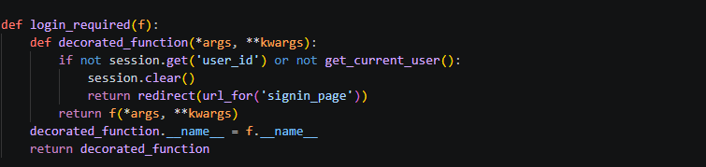
- Authentication Routes: /api/auth/signup and /api/auth/signin hash/verify passwords via Werkzeug and set the Flask session; /api/auth/logout clears it:
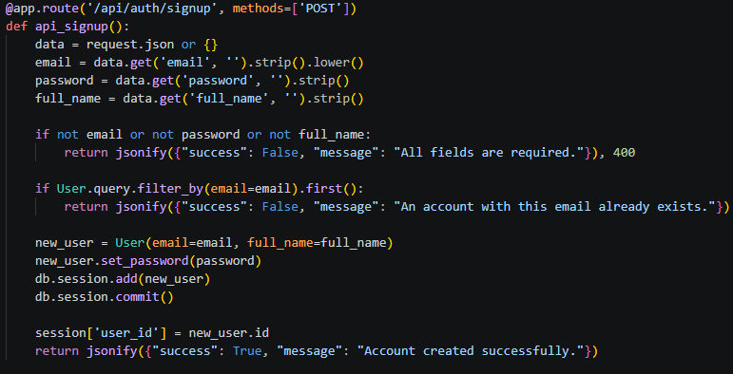
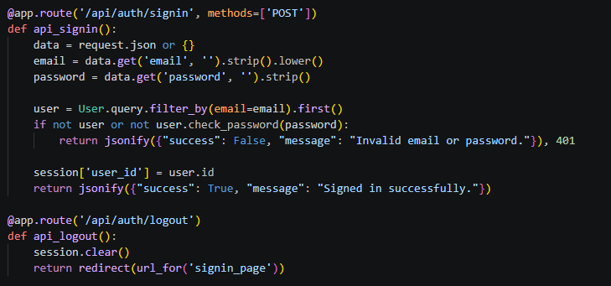
- Page Routes: Standard render_template routes serve every page — /signin, /signup, /dashboard, /data, /agents, /scenarios, /scenarios/<id>, /scenarios/<id>/agents/<slug>, /patients, /appointments, /beds, /labs, /pharmacy, /staffing, /discharge, and /reports — each protected by @login_required except the public landing/auth pages.
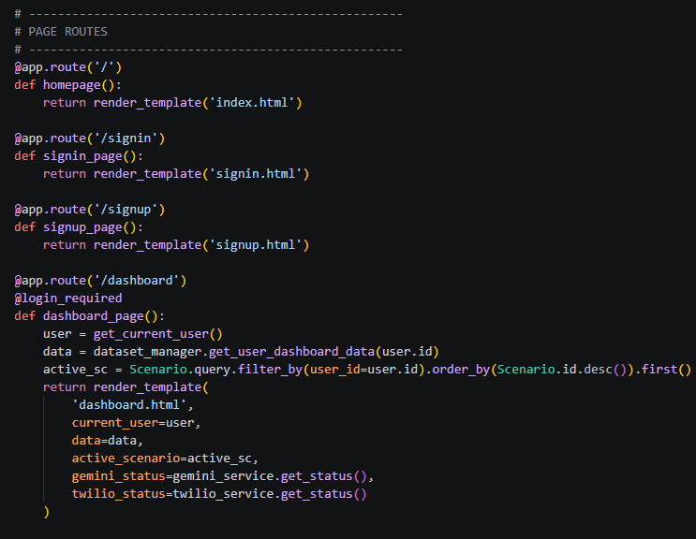
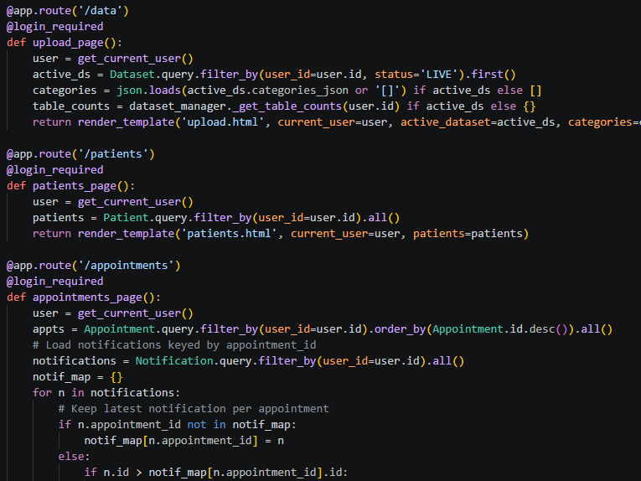
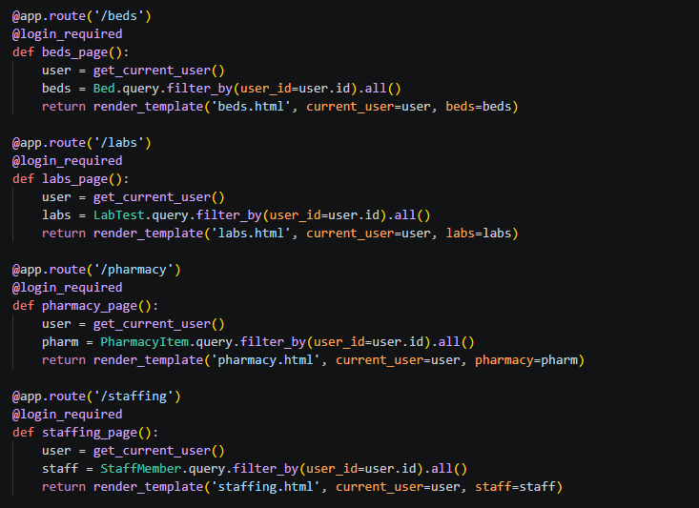
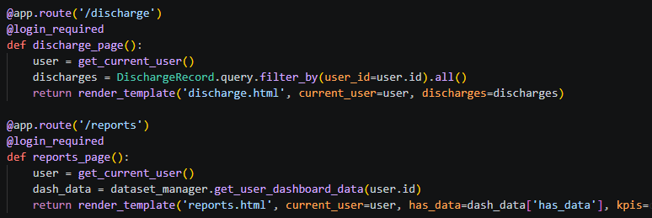
- Dataset Upload API: POST /api/dataset/upload saves the uploaded file and calls dataset_manager.process_and_ingest(), returning ingestion results as JSON:
- Scenario APIs: POST /api/scenarios/create builds and analyzes a new scenario; POST /api/scenarios/<id>/run executes the full agent pipeline; GET /api/scenarios/<id>/agents/<slug>/results returns a single agent's stored results; DELETE /api/scenarios/<id> removes a scenario.
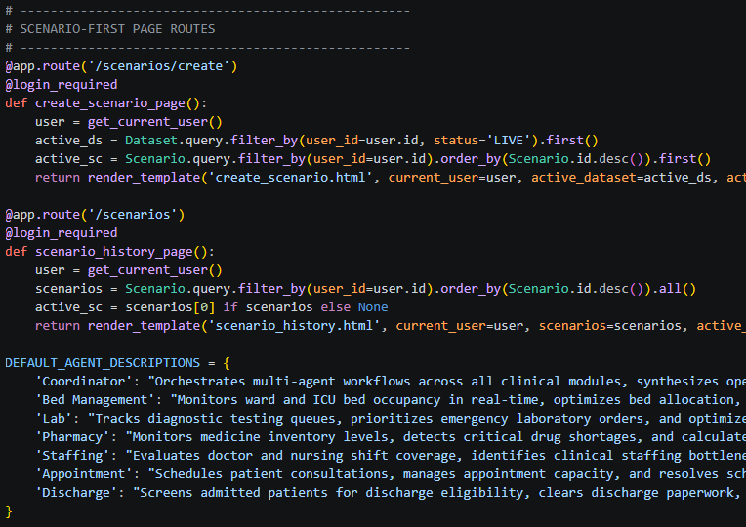
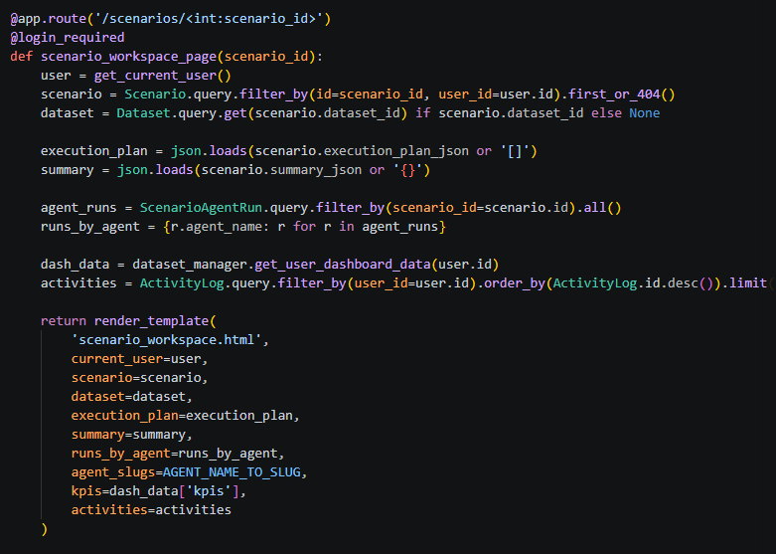
- Appointment Workflow APIs: /api/appointments/analyze-condition, /available-doctors, /available-slots, /doctor-schedule, and /create together drive the guided appointment-booking flow, backed by services/appointment_workflow.py.
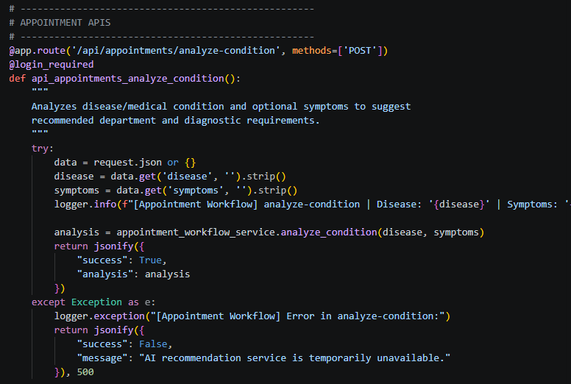
- Twilio WhatsApp Webhooks: /api/twilio/whatsapp/incoming, /api/whatsapp/webhook, and related routes receive inbound WhatsApp sandbox-join messages and register patient opt-ins; a background daemon thread (_start_whatsapp_inbound_sync_worker) polls for new joins every few seconds.
- Live Agent Event Stream: GET /api/agent-events exposes the SSE stream described in Milestone 2:
- Health & Diagnostics APIs: /api/gemini/health tests the live Gemini connection; /api/dataset/status and /api/dataset/table-counts report live per-table record counts for the Dataset Management page.

Milestone 4: Frontend Development
Milestone 4 covers the 19-page Jinja2 frontend, the shared visual design system, and the vanilla-JavaScript layer that drives live dashboards, dataset uploads, and real-time agent visualizations.

Activity 4.1: Designing and Developing the User Interface
- Base Template Structure: Each page (templates/*.html) extends a common layout with a left sidebar (Dashboard, Dataset Management, AI Agents Hub, Patients, Appointments, Beds, Labs, Pharmacy, Staffing, Discharge, Reports) and a top header.
- Visual Design System: static/css/style.css defines a light indigo/violet SaaS theme (--primary: #6366F1, soft gradient background, rounded 14–20px cards, layered shadows) built with the Plus Jakarta Sans and Outfit Google Fonts.
- Empty-State Components: KPI cards render “—”, charts show “No hospital data available”, and every agent badge shows “Waiting for Dataset” until a dataset is uploaded, directly reflecting the Zero Preloaded Data Policy in the UI.
- Dataset Upload Page: templates/upload.html provides a drag-and-drop zone for CSV/XLSX/JSON files and a live 6-step ingestion progress sequence.
- AI Agents Hub & Scenario Workspace: templates/agents_hub.html, scenario_workspace.html, and scenario_agent.html render the Coordinator and six specialized agents as cards that transition through Waiting → Running → Completed states, each opening into a per-agent results workspace with operational tables and charts.
- Operational Module Pages: patients.html, appointments.html, beds.html, labs.html, pharmacy.html, staffing.html, discharge.html, and reports.html each render live, dataset-driven tables and Plotly charts scoped to the signed-in user.

Activity 4.2: Creating Dynamic Content Rendering with JavaScript
- Dataset Upload Handling (static/js/upload.js): Handles drag-and-drop, sends the file to /api/dataset/upload via the Fetch API, and renders the ingestion progress sequence from the JSON response.
- Dashboard & Charts (static/js/dashboard.js): Fetches live KPI/table counts from /api/dataset/status and /api/dataset/table-counts and renders Plotly charts, refreshing automatically after a dataset is uploaded or a scenario completes.
- Live Agent Visualization (static/js/agents.js): Opens an EventSource connection to /api/agent-events and updates each agent card's status badge and progress state in real time as SSE messages arrive, without any page reload.
- Authentication Forms (static/js/auth.js): Submits sign-up/sign-in forms asynchronously to /api/auth/signup and /api/auth/signin and redirects to /dashboard on success.
- Shared Utilities (static/js/main.js): Provides shared UI helpers — toast notifications, sidebar toggling, and Fetch API wrapper functions — reused across every page.

Milestone 5: Deployment
In Milestone 5, the focus is on deploying CareSync AI locally, verifying correct operation end-to-end with a generated sample dataset, and confirming the AI and notification integrations behave correctly in both “fully configured” and “no API keys” modes.

Activity 5.1: Preparing the Application for Local Deployment
- Set Up a Virtual Environment:
- Generate a Sample Dataset (Optional): create_sample_dataset.py generates sample_hospital_data.xlsx for immediate drag-and-drop testing without needing a real hospital export:
- Configure Environment Variables:All of these are optional except SECRET_KEY: GEMINI_API_KEY and the three TWILIO_* values simply switch the platform from rule-based/Mock Mode to live AI and live SMS/WhatsApp when present.

Activity 5.2: Local Testing and Verification
- Start the Flask Development Server:
- Access the Application: Open a browser and navigate to http://localhost:5000.
- Verify the Empty State: Sign up for a new account and confirm every KPI card shows “—”, every chart shows “No hospital data available”, and all 7 agents show “Waiting for Dataset”.
- Upload a Dataset: Go to Dataset Management (/data) and drag-and-drop sample_hospital_data.xlsx; watch the 6-step ingestion sequence complete and confirm the dashboard, charts, and module pages populate with live data.
- Run an Emergency Surge Simulation: From the dashboard, click “⚡ Run Emergency Surge Simulation” (or create a scenario from /scenarios/create) and confirm the Coordinator and six agents transition Waiting → Running → Completed, routine appointments are rescheduled, beds are freed, and dashboard metrics update live.
Activity 5.3: Public Deployment via Ngrok
Ngrok creates a secure tunnel from a public URL to your local Flask server, making the app accessible from anywhere without a cloud hosting provider.
Install Ngrok and pyngrok:
- Install the pyngrok Python wrapper, which manages Ngrok programmatically within your Python project:
- pip install pyngrok
- Download and install the Ngrok client from https://ngrok.com/download.
- Click on “Microsoft Store Installer”.
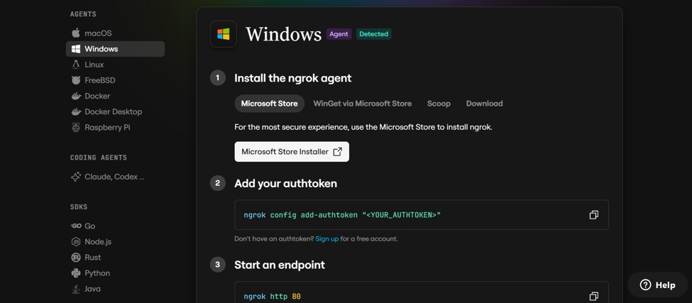

Configure Your Ngrok Authtoken:
- Sign up at ngrok.com and copy your authtoken from the Ngrok dashboard.
- The run_public.py script sets the authtoken automatically using:
ngrok.set_auth_token("YOUR_NGROK_AUTHTOKEN")
- Replace the TOKEN value in run_public.py with your own Ngrok authtoken before running.

Run the Public Deployment Script:
- Instead of running app.py directly, launch run_public.py to start both the Ngrok tunnel and the Flask server:
python run_public.py
- The script opens an HTTP tunnel on port 5000 and prints the live public URL in the terminal:
======================================================
YOUR PUBLIC WEBSITE URL IS LIVE!
URL: https://xxxx-xx-xx-xxx-xx.ngrok-free.app
======================================================
- Share this URL with anyone who can access your CaptionAI app directly from their browser without any installation.
Important Notes:
- debug=False is required in run_public.py to prevent Flask from spawning a reloader process, which would interfere with Ngrok’s tunnel management.
- The public URL changes each time you restart run_public.py (on the free Ngrok plan). For a persistent URL, upgrade to a paid Ngrok plan and configure a reserved domain.
- Ngrok free tier sessions expire after a few hours of inactivity. Restart run_public.py to get a new URL when this happens.

Milestone 6: Conclusion

Exploring the Website's Web Pages:

Landing Page:
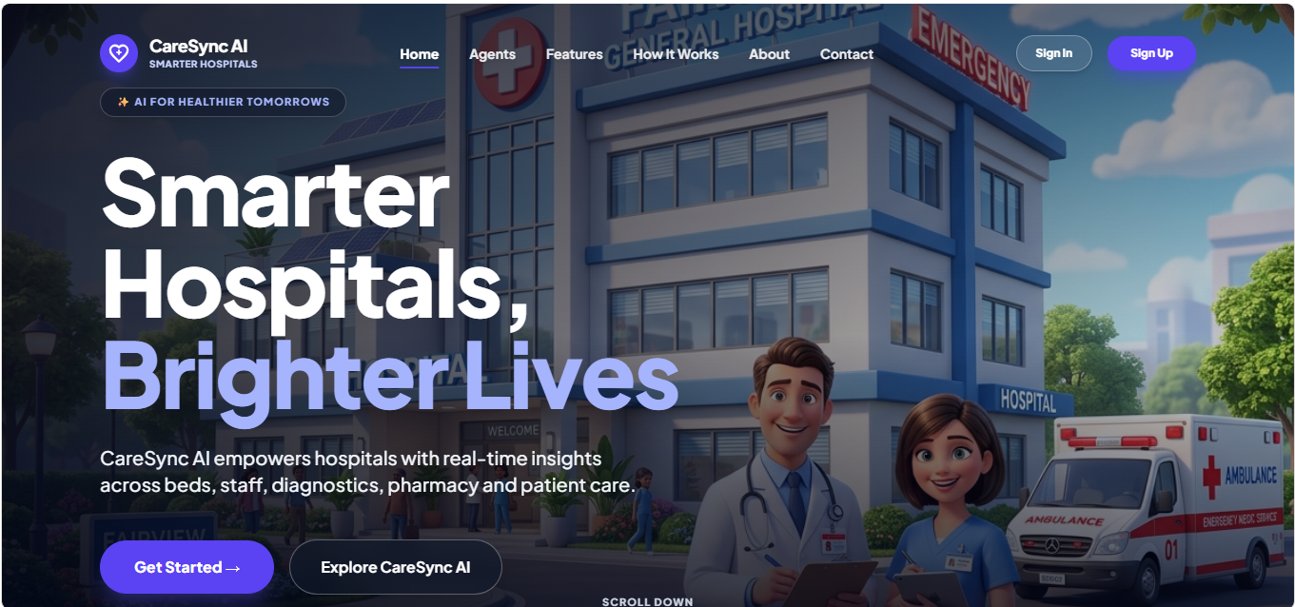
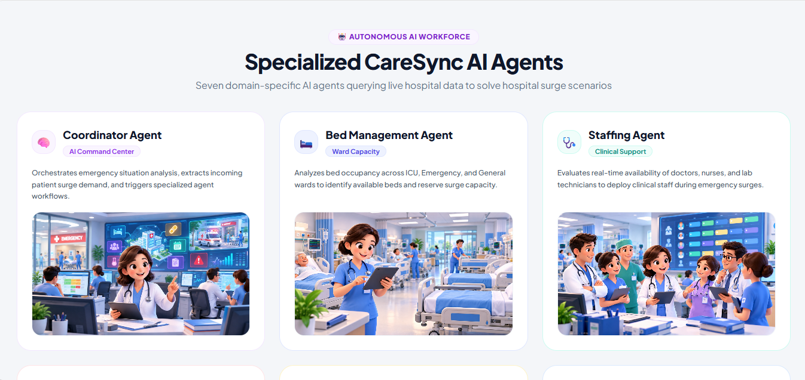
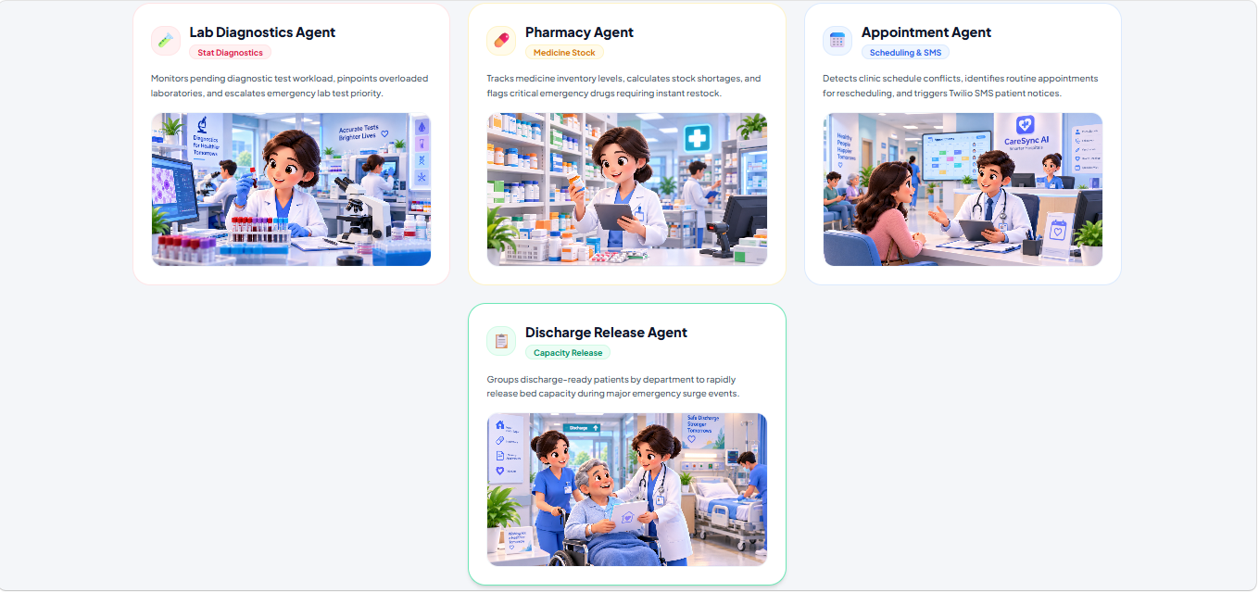
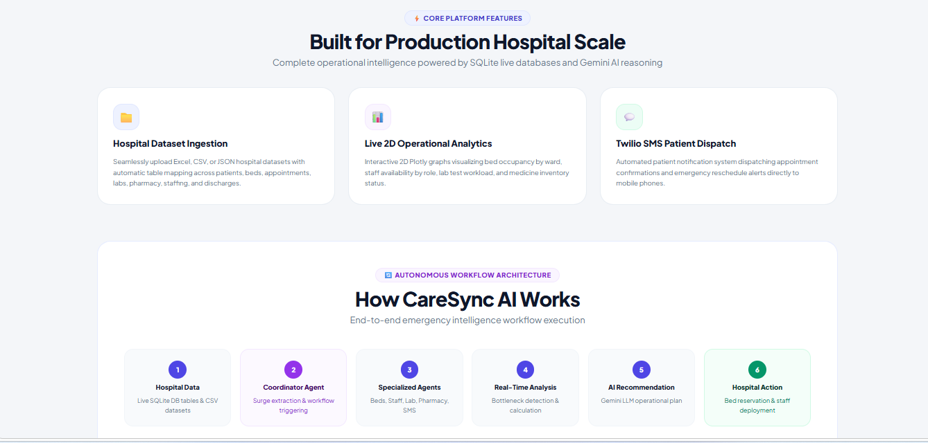
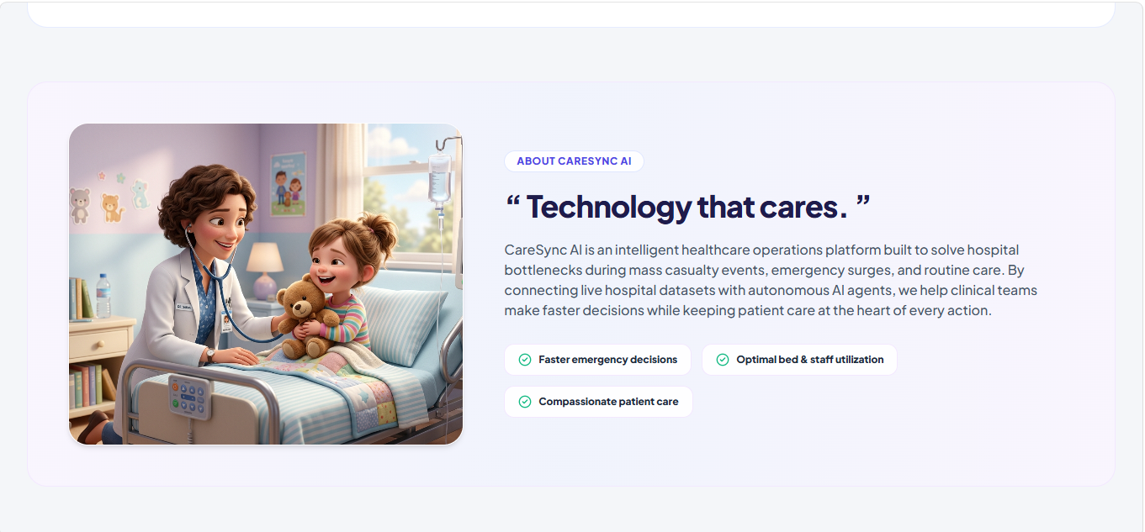
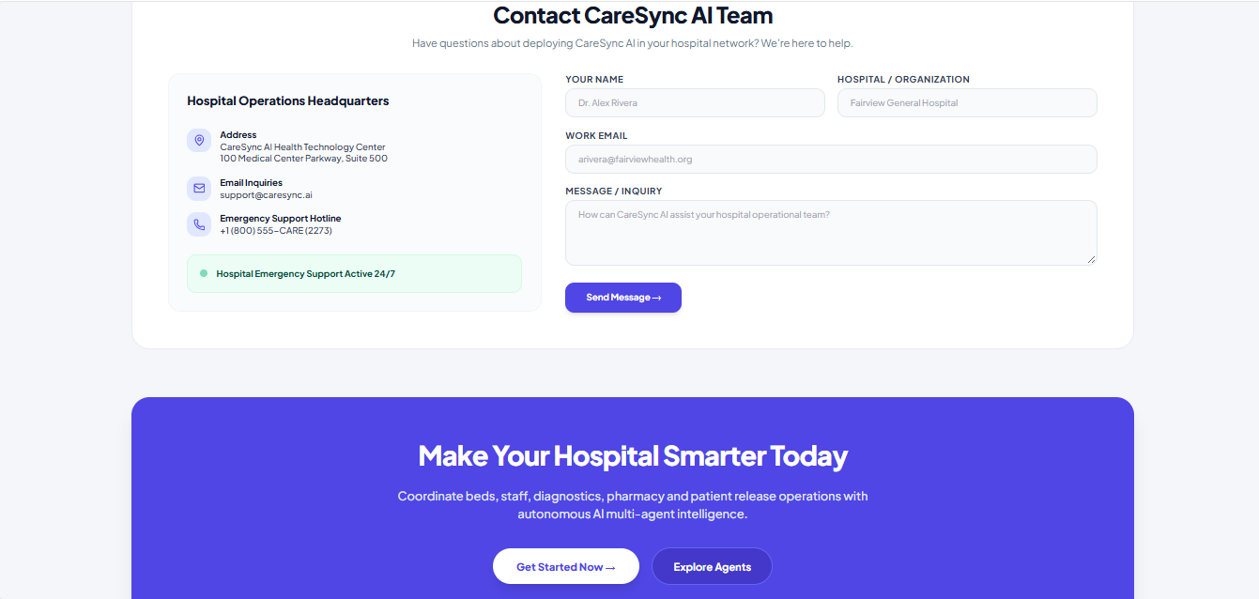
Description:The public marketing/landing page (templates/index.html) introduces CareSync AI — “Smarter Hospitals, Brighter Lives” — with a hero section, feature highlights covering the multi-agent engine and Zero Preloaded Data Policy, and Sign In / Sign Up call-to-action buttons.

Sign In / Sign Up Pages:
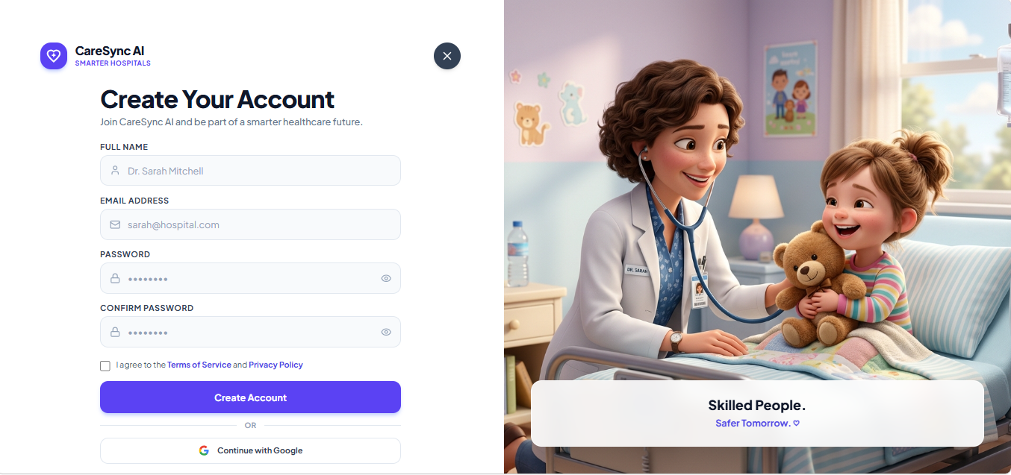
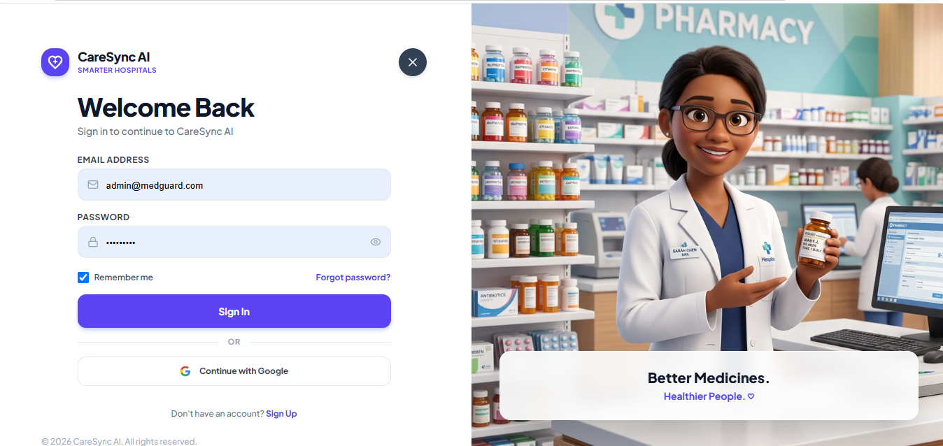
Description:Templates/signin.html and templates/signup.html provide the authentication forms. Sign-up collects full name, email, and password; both forms submit asynchronously to the /api/auth endpoints and redirect to the dashboard on success, showing inline error messages for invalid credentials or duplicate accounts.

Dashboard:
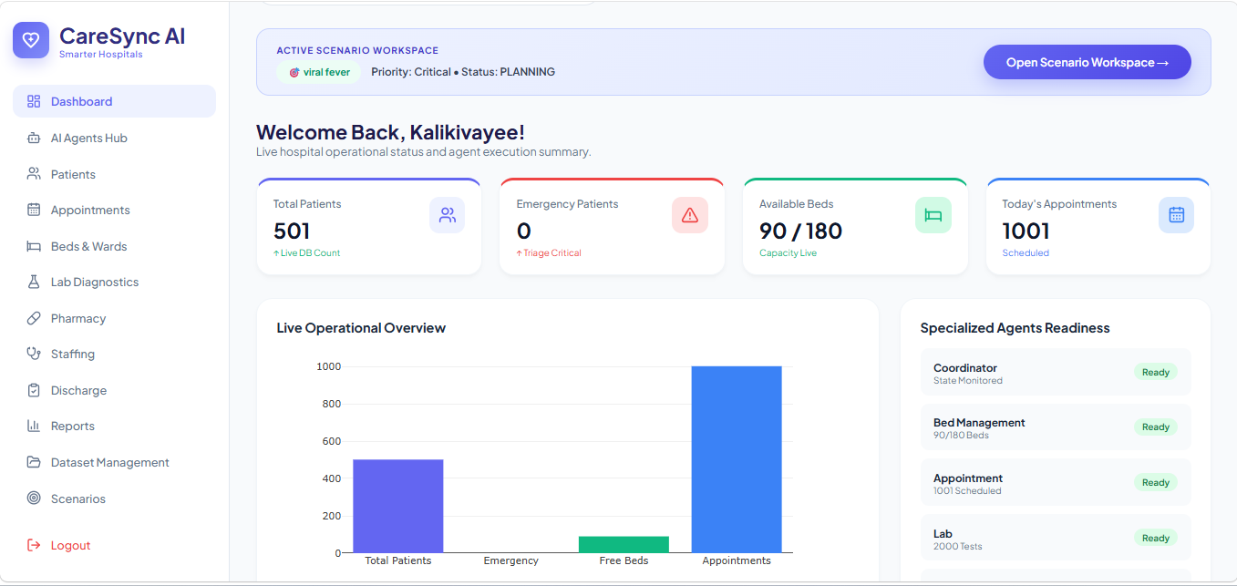
Description:The main operational overview (templates/dashboard.html) displays KPI cards (available beds, staff, pending labs, critical medicines, today's appointments, discharge-ready patients), live Plotly charts, an “⚡ Run Emergency Surge Simulation” action, and a live agent-status strip — all showing empty placeholders until a dataset is uploaded.

Dataset Management (Upload):
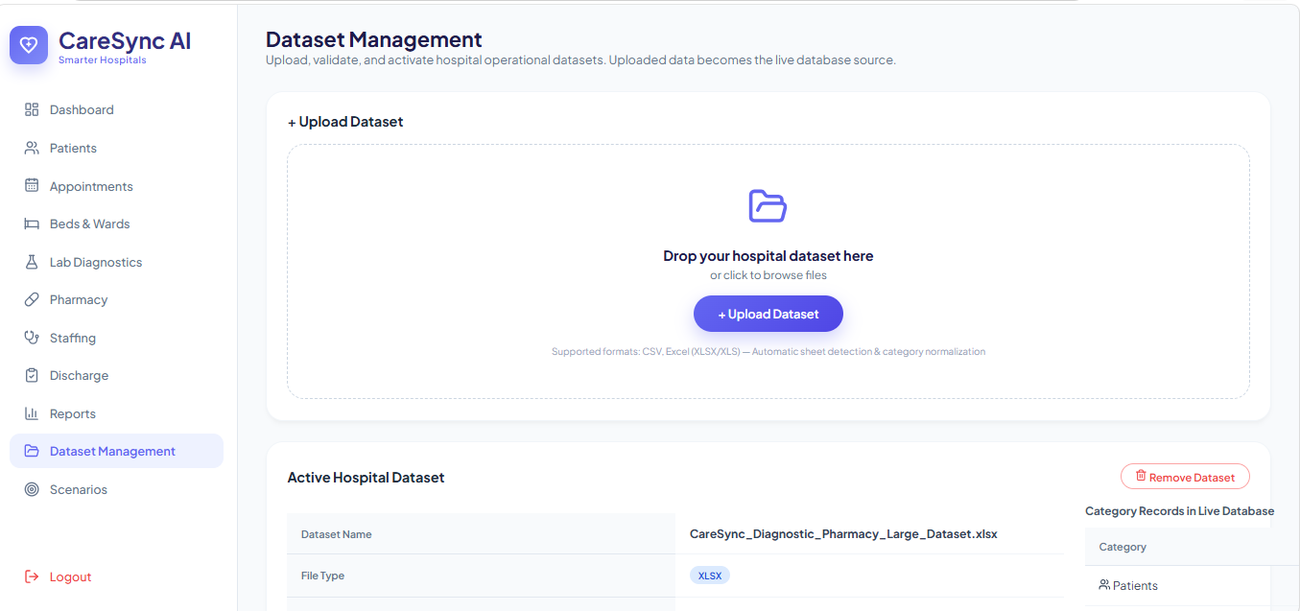
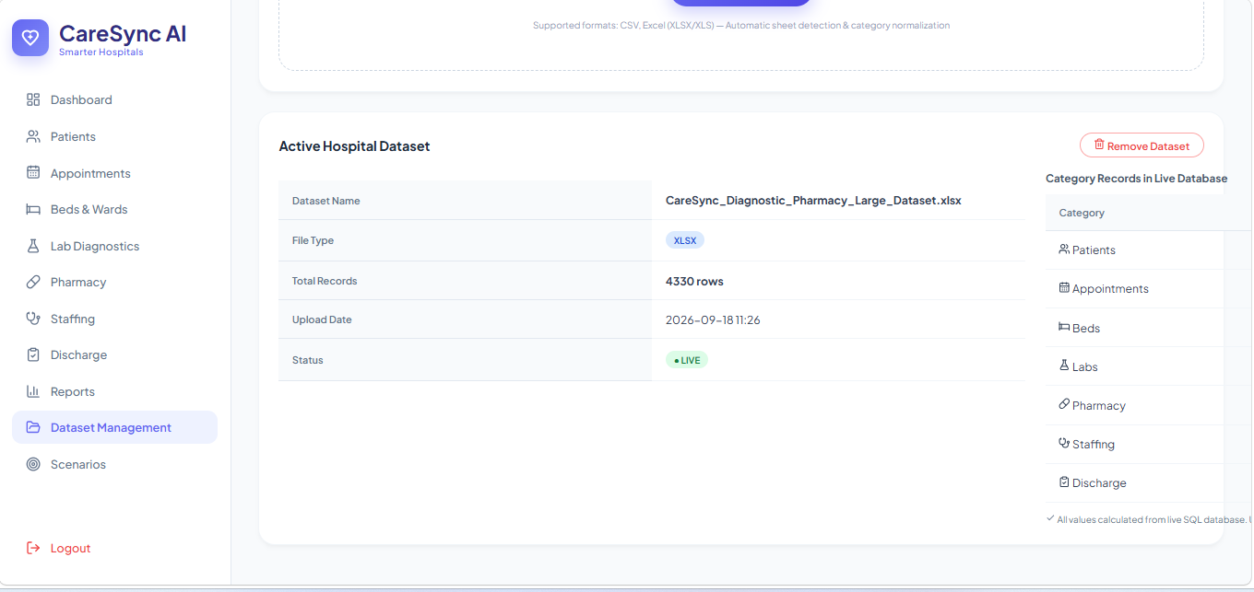
Description:Templates/upload.html lets a user drag-and-drop or browse for a CSV, XLSX, or JSON hospital dataset. On upload, a 6-step progress sequence (parsing → category detection → column mapping → ingestion → validation → activation) plays out, and per-table live record counts are displayed once ingestion completes.

AI Agents Hub:
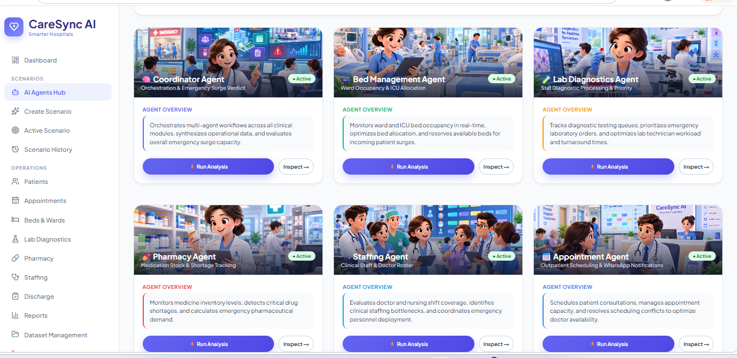
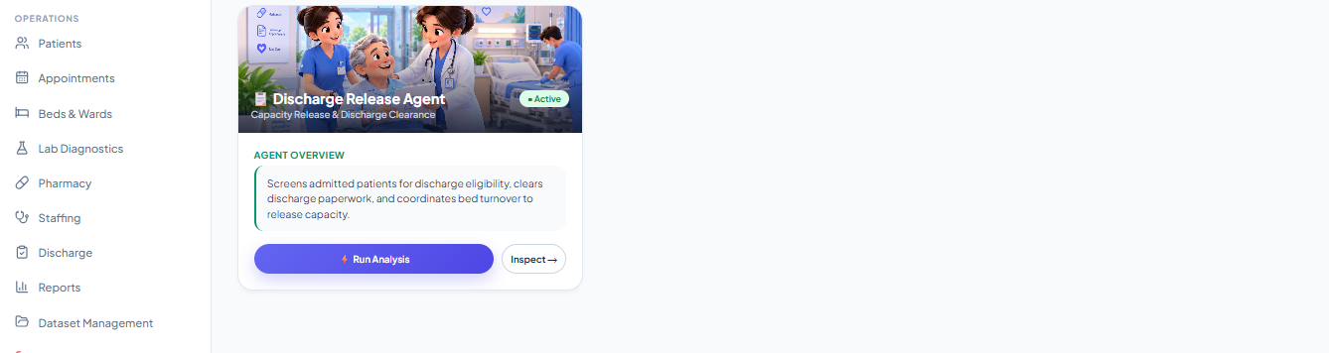
Description:Templates/agents_hub.html displays the Coordinator Agent and all six specialized agents as individual cards, each showing its current status badge (Waiting for Dataset / Running / Completed), a short description of its responsibility, and a link into its dedicated workspace.

Create Scenario & Scenario Workspace:
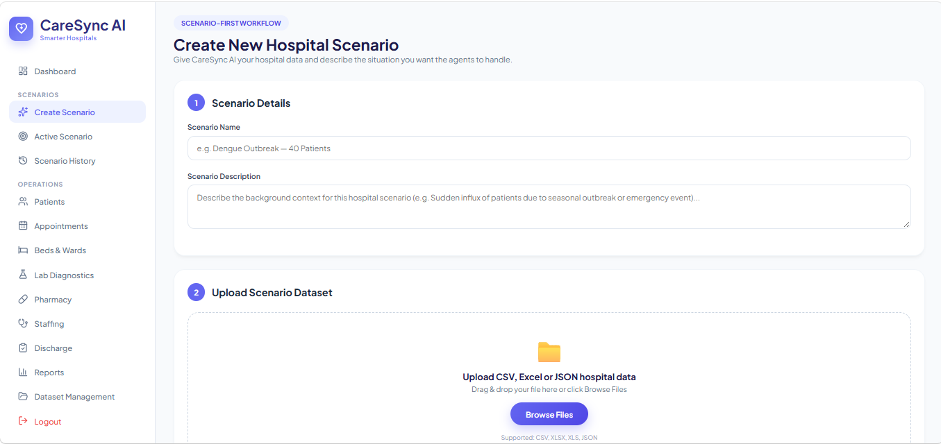
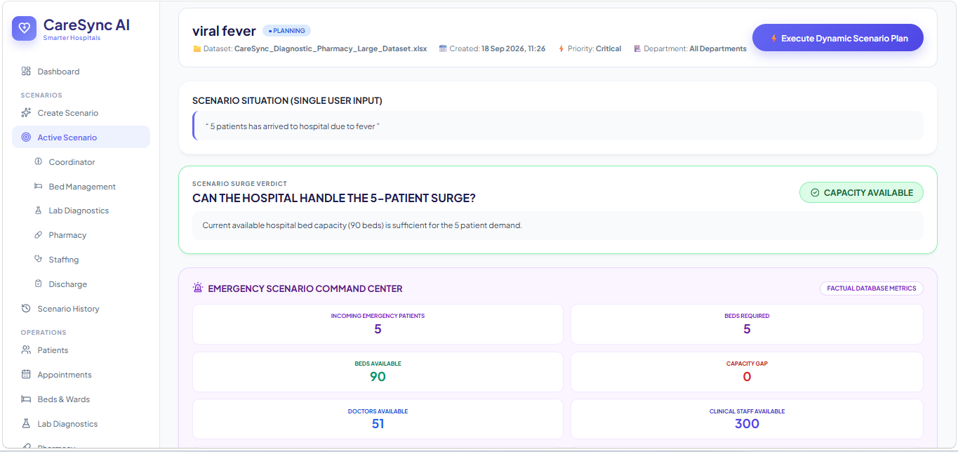
Description:Templates/create_scenario.html lets a user describe an emergency scenario in free text (e.g. “40 incoming emergency patients”) along with a name, type, priority, and department. Once created, templates/scenario_workspace.html shows the live pipeline of all seven agents executing against the scenario, each expandable into templates/scenario_agent.html for that agent's structured findings, operational record tables, and AI-generated narrative summary. templates/scenario_history.html lists all previously run scenarios.

Operational Module Pages:
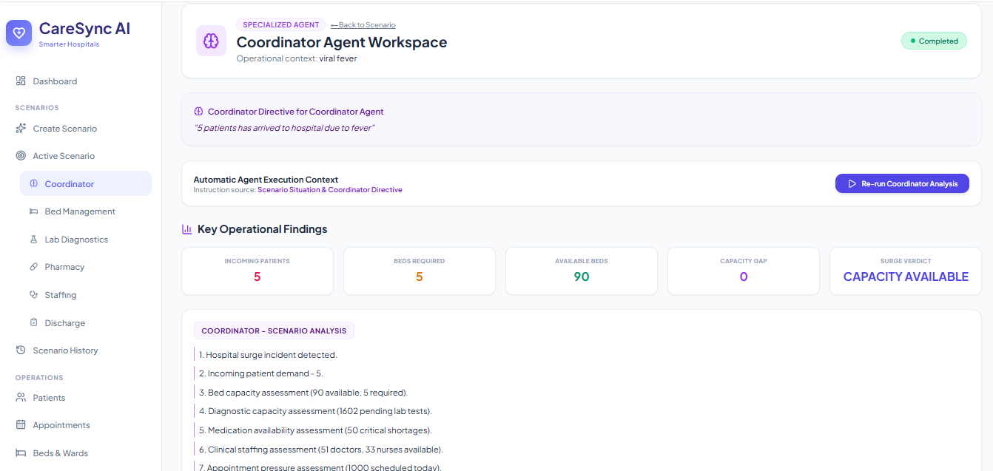
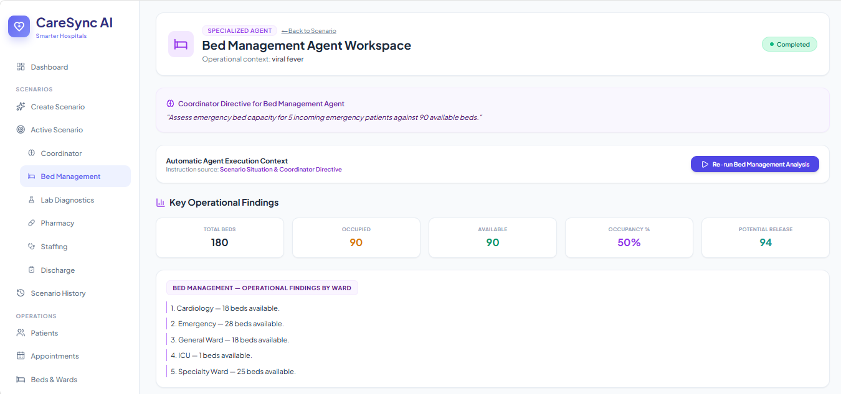
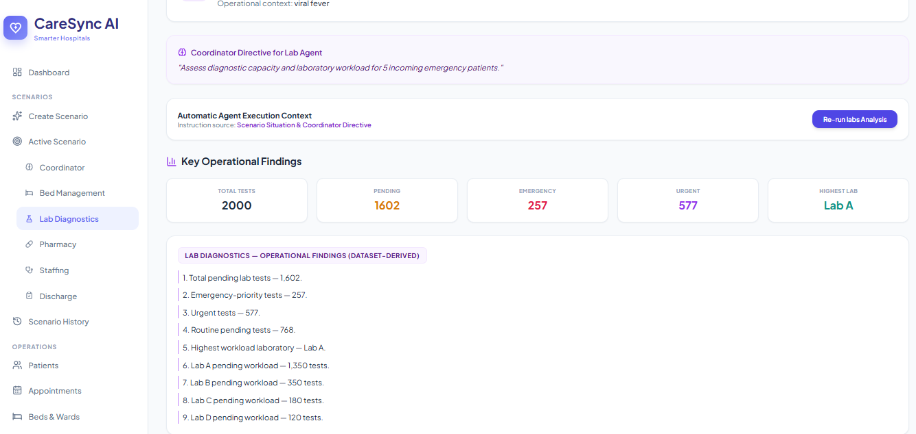
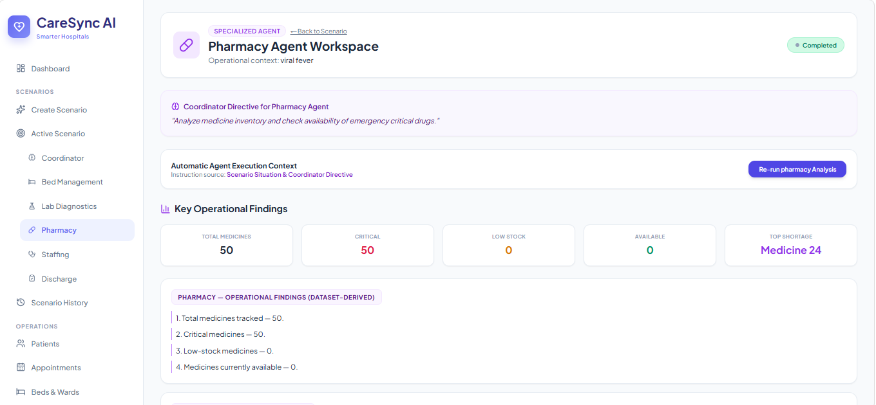
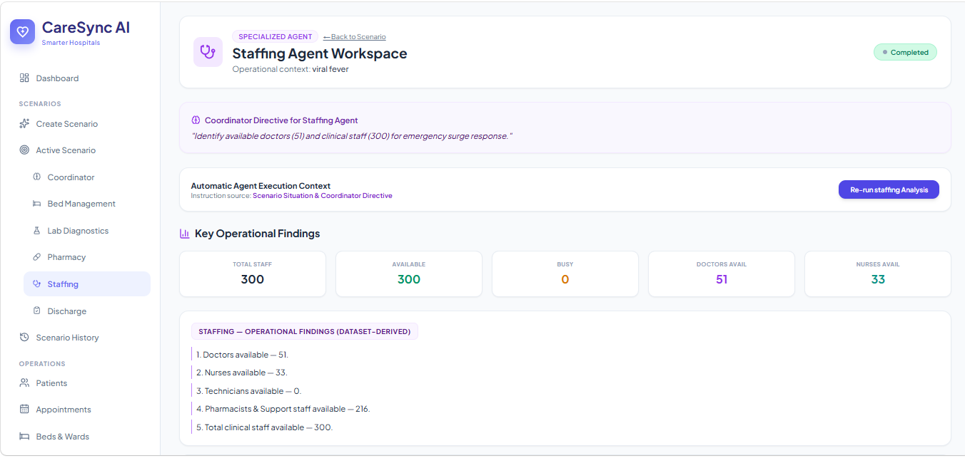
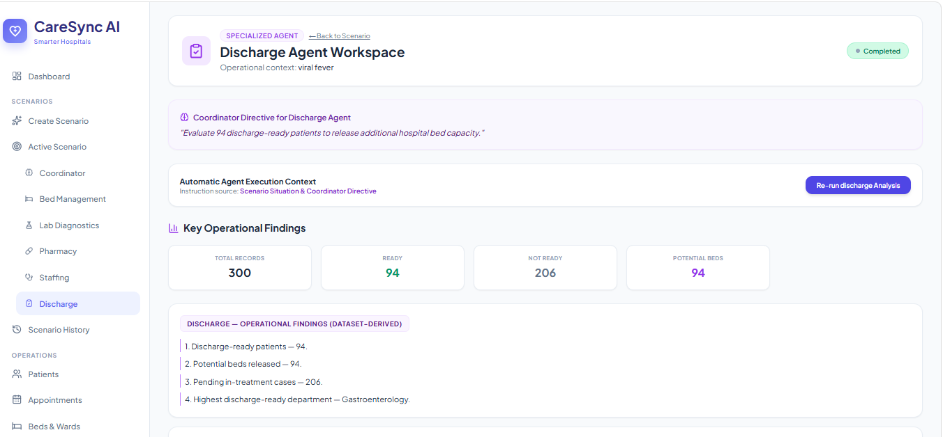
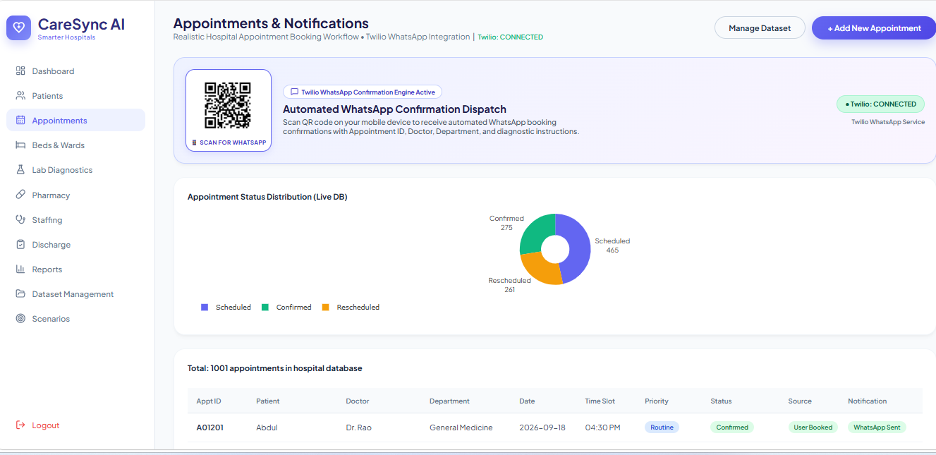

Description:Patients, Appointments, Beds & Wards, Lab Diagnostics, Pharmacy Inventory, Staffing, Discharge, and Reports & Operational Analytics each present a live, dataset-driven table and supporting Plotly visualizations for that domain, scoped to the signed-in user's uploaded dataset. The Appointments page additionally exposes the guided booking workflow (condition analysis → doctor/department suggestion → slot selection → SMS/WhatsApp confirmation).

Conclusion:
CareSync AI is a multi-agent, database-driven hospital operations platform built with Flask, SQLAlchemy, and SQLite, that turns a hospital's own uploaded dataset into a live operational picture and coordinates a seven-agent emergency-response pipeline — Coordinator, Bed Management, Appointment, Lab, Pharmacy, Staffing, and Discharge — across it. Google's Gemini 2.5 Flash model provides semantic dataset mapping and natural-language operational summaries, gracefully degrading to deterministic rule-based logic whenever no API key is configured, while Twilio delivers real SMS/WhatsApp patient notifications with an automatic Mock Mode fallback. Real-time visibility into agent execution is delivered through Server-Sent Events, and the project's strict Zero Preloaded Data Policy ensures every number shown to a user is grounded in data they actually uploaded.
The project, which spanned service provisioning, multi-agent engine design, backend API development, and a fully live-updating frontend, demonstrates how a structured multi-agent architecture combined with generative AI can support real hospital decision-making under surge conditions. Looking ahead, CareSync AI has clear paths for expansion, including predictive surge forecasting from historical scenario runs, role-based access for different hospital departments, deeper LangGraph-style stateful agent orchestration with inter-agent negotiation, and richer analytics on the Reports page — positioning the platform to grow from a scenario simulator into a continuously running hospital operations co-pilot.

